InTouch Project Development Document (Programming Part)

Michael Luan

1. Set up two Oculus devices.
2. Building the Project.
3. Set up the basic synchronize of two players’ movement.
4. Set up the basic synchronize of two Oculus devices.
5. Spawn Points of two players.
6. **Set Up Two Oculus Devices**

**For the First step, we linked two Oculus devices including Rift and Touch to two separate test computer, and use our own computer to remote control the test computer. However, we found that when using remote mode to control the test computer to test our game, the oculus runtime SDK could not work properly. I have tried different methods such as re-install the runtime SDK and use administration account, but it still not works. Finally, we decided to use our own computer for development, and use GitHub to manage the version of our project, then use test computer to pull from Git and test.**

1. **Building the Project**

**After configuration and download the needed oculus plugin and GitHub environment, I build our project called InTouch, and initial the GitHub project. Here is our project GitHub address:**

<https://github.com/luanhaoqing/InTouch>

1. **Set up basic synchronize of two player movement**

**We went through the official tutorial of unity network functions, and build a basic scene including the synchronize of two player’s movement using NetworkManager, NetworkIdentity, and NetworkTransform. Then the two player could see each other’s movement in unity window. This unity package of network is based on the model of one player host the server, and the other could join the game by entering the host’s IP address.**

1. **Set up basic synchronize of two Oculus device.**

**I met some difficulties in setting up the two Oculus devices. At first I did the same thing as I did before for the two Oculus devices. Each time when player joined the game, it will automatically generate an Oculus prefab. However, I found it works very wired, it would blink, and also control the other’s movement. After I tried different possibilities, I found the reason is that the built in function of Oculus would try to control both of the prefabs of Oculus. So I tried to modify codes in the Oculus controller function, while it still not works good.**

**Finally, I figured out a way to solve this problem without modifying codes of Oculus. I use the idea of proxy to create a new set of objects to reflect the movement of the player.** 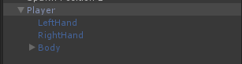

**I use codes which attached on the Player object to get the movement of the Oculus and touch and then pass them to the objects which will be synchronized by the other. After several tries, I finally find it should use Network Transform Child function instead of Network Transform function. So the configuration of Player is like this:**

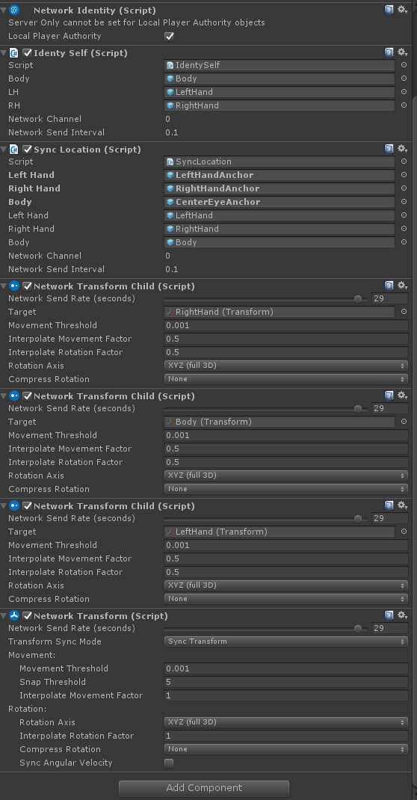

**And each part of the objects such as Left Hand, Right Hand has a network transform attached.**

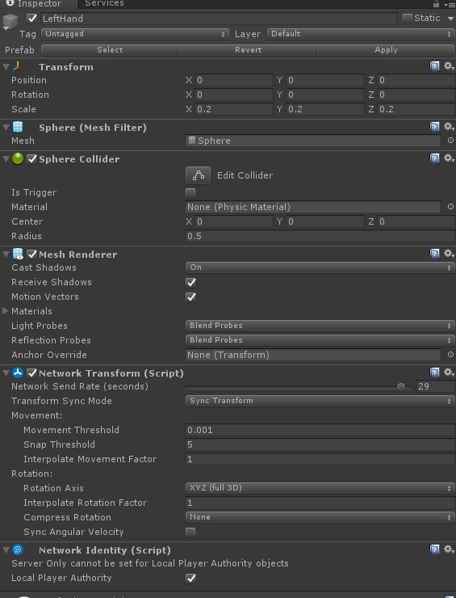

1. **Spawn Points of players**

**I use Network Start Position function of Unity to realize the basic function. Firstly, I added two Spawn points, and the two player prefabs would be generated there. However, I find that because of the player would be synchronized to the oculus, so that in start function, I set the Oculus position to Spawn position.**